Faculty of Engineering Sciences and Technology

Activity # 01
Course: | Final Year Project 2 | Coordinator: | Dr. Atiya Masood
Marks Allocated: | 10 Marks | Time Allocated: | 1 Week
CLO Allocated: | CLO-1 (BT Level- C3), CLO-2 (BT Level- C4), CLO-8 (BT Level- A2) and CLO – 10 (BT Level- A1) | PLO Allocated: | PLO1- Engineering Knowledge, PLO2- Problem Analysis, PLO 10- Communication and PLO11- Project Management

PROJECT TITLE: CAMPUS CARE
- Funding / Sponsoring Organization (if any): NA
- Project Start Date:
- Project Finish Date:

- Project Summary (200 - 300 words):

The CampusCare app offers a comprehensive solution for streamlining health services within university communities, facilitating centralized access to vital health resources and appointments. Its user-friendly interface caters to students, faculty, doctors, and staff, ensuring seamless registration processes and robust data security measures to safeguard sensitive information. With features like appointment scheduling, virtual consultations, notification alerts, and comprehensive health records, CampusCare promotes proactive well-being and efficient healthcare management. Challenges in development, such as security concerns and privacy regulations, are met with solutions like encryption, user-friendly interfaces, and routine updates. Motivated by a commitment to elevate university health services, CampusCare stands as more than just an application but as a strategic investment in enhancing professionalism and efficacy in health infrastructure. Its objectives span from developing registration modules to providing user education, supported by research and academic collaborations to ensure its continuous improvement and adaptation to evolving needs. The benefits extend beyond the university community, with advanced technological publications, comprehensive databases, and opportunities for academic and professional growth for the project team. Overall, CampusCare represents a significant step towards promoting a healthy campus environment and raising the standard of health services.

- Objective, Benefits and Deliverables
Objectives:
- Develop seamless registration modules for students, faculty, doctors, and staff.
- Ensure robust data security with encryption and secure authentication.
- Implement an efficient appointment scheduling system.
- Facilitate virtual consultations for convenient healthcare access.
- Establish a notification system for timely updates and alerts.
- Maintain detailed health records for holistic healthcare management.
- Provide dedicated user support and feedback mechanisms.
- Offer educational resources promoting user health education.
- Integrate emergency contact information and language flexibility.
- Streamline leave management with medical prescription submission.
- Seamlessly integrate with existing health records and ensure secure document storage.
- Facilitate user education with in-app tutorials and resources.
- Provide contact information for easy communication and support.
Research Objectives:
- Conduct user research to identify health management needs within the campus community.
Academic Objectives:
- Collaborate with educational institutions for research partnerships on CampusCare's impact on student well-being.
Commercial Objectives:
- Explore partnerships with entities in education and healthcare for app deployment and expansion.
Other Objectives:
- Continuously update the app with the latest medical information, technologies, and security patches.
Benefits:
Advanced Technological Publications: Publication of cutting-edge research findings and technological advancements achieved during the project.
Comprehensive Databases:Development of extensive databases containing valuable project data, contributing to knowledge repositories in the field.
Academic Community:Researchers, scholars, and students will benefit from the advanced publications
and databases, enhancing academic knowledge.

Industry Professionals:Professionals in relevant industries will gain insights from the project outputs, fostering innovation and industry growth.

Project Team:The project team members will gain experience, skills, and recognition through their contributions, aiding in their professional development.

Deliverables:
- Seamless user registration modules.
- Robust data security measures.
- Efficient appointment scheduling system.
- Virtual consultation feature.
- Notification system for updates.
- Comprehensive health records management.
- Dedicated user support channels.
- Feedback mechanism for user input.
- Educational resources on health.
- Integration of emergency contacts.
- Language selection feature.
- Streamlined leave management.
- Integration with health records.
- Secure document storage.
- In-app tutorials for user education.
- Contact information for support.

- Implementation Plan

DEVELOPMENT / RESEARCH METHODOLOGY

SDLC MODEL:

The Agile Software Development Life Cycle (SDLC) model is well-suited for the CampusCare project due to its adaptability, user-centric approach, and emphasis on continuous value delivery. CampusCare, designed to streamline health services for students, faculty, and campus employees, requires a flexible development process to accommodate dynamic features. Agile's iterative and incremental nature allows for seamless adaptation to changing requirements, ensuring the system evolves alongside the diverse needs of users. The user-centric focus of Agile aligns with CampusCare's goal of providing a user-friendly health management system, fostering improved campus-wide health experiences. Additionally, Agile's emphasis on efficient collaboration and communication supports the project's collaboration with commercial partners in the education and healthcare sectors. The model's risk management features are particularly valuable for CampusCare, dealing with sensitive health information, as Agile enables early identification and mitigation of potential risks. In essence, the Agile SDLC model is chosen for CampusCare to foster a responsive and collaborative development process, ultimately delivering a comprehensive and dynamic health management solution.

- Phase 1: Initial Setup and User Registration
- User Registration
- Student Registration
- Faculty Registration
- Doctors Registration
- Employee Registration
- Data Security
- Basic security measures
- Phase 2: Core Functionality and Basic Communication
- Appointment Management.
- Scheduling with basic features.
- Notification System.
- Basic alerts for appointments.
- User Support.
- Initial channels for addressing queries.
Phase 3: Enhanced Communication and Consultation
- Online Consultation.
- Basic virtual consultations.
- Consultation History.
- Record keeping for appointments.
- Prescription Download.
- Capability for users to download prescriptions.
Phase 4: User Engagement and Feedback
- App Tutorial.
- User-friendly guidance.
- User Feedback.
- Feedback mechanism.
- Tips and Resources.
- Initial educational content.
Phase 5: Extended Features and Integration
- Language Selection.
- Option for users to choose language.
- Integration with Health Records.
- Initial steps for data integration.
- Secure Document Storage.
- Basic secure storage.
Phase 6: Advanced Functionality and Health Records
- Health Record.
- Comprehensive health record features.
- Profile Management.
- User ability to manage profiles.
- Feedback of Doctor.
- Full-fledged feedback system.
Phase 7: Leave Management and Document Handling
- Leave Management.
- Leave application and tracking.
- Secure Document Storage.
- Advanced secure storage.
- Leave History.
- Comprehensive history of leave applications.
Phase 8: User Education and Contact Information
- User Education.
- 0Full-fledged educational resources.
- Contact Information.
- Complete contact information for support.
Phase 9: Final Testing and Optimization
- Comprehensive testing of all features.
- Optimization for performance and user experience.
Phase 10: Deployment and Ongoing Support
- Full deployment of the system.
- Continuous support and maintenance.\

FLOWCHART:

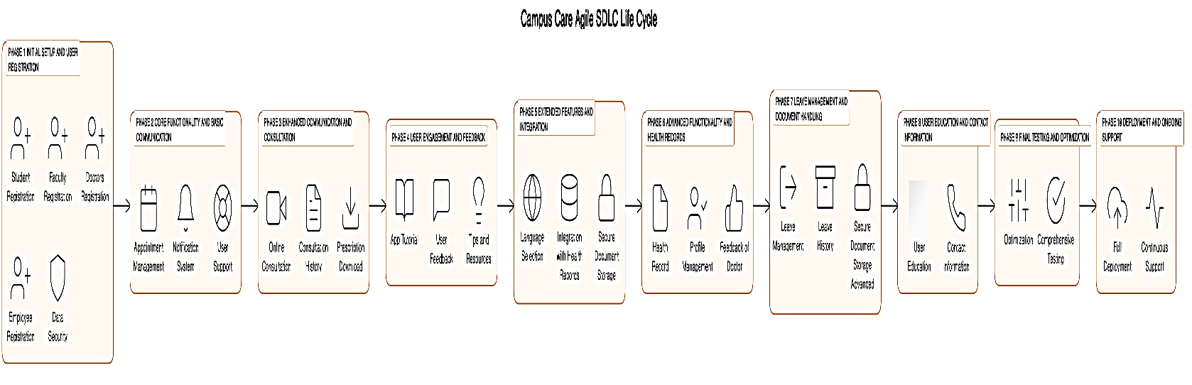

GANTT CHART
WEEKS | DELIVERABLES | DEADLINES
WEEK 1 | - Define project scope, objectives, and requirements.  - Conduct market research and competitor analysis. | Apr 11, 2024
WEEK 2 | - Create user personas and define user stories.  - Develop a project plan and timeline. | Apr 18, 2024
WEEK 3 | - Design the system architecture. | Apr 25, 2024
WEEK 4 | - Create wireframes and UI/UX design for the app. | May 2, 2024
WEEK 5 | - Define database structure and data models | May 9, 2024
WEEK 6 | - Plan for data security measures. | May 16, 2024
WEEK 7 | - Set up the development environment. | May 23, 2024
WEEK 8 | - Implement user registration modules (Doctors and Patients). | May 30, 2024
WEEK 9 | - Work on data security features and integration. | Jun 6, 2024
WEEK 10 | - Implement appointment scheduling and notification features. | Jun 13, 2024
WEEK 11 | - Develop online consultation functionality. | Jun 20, 2024
WEEK 12 | - Work on prescription download and upload features. | Jun 27, 2024
WEEK 13 | - Conduct unit testing and integration testing. | Jul 4, 2024
WEEK 14 | - Deploy the CampusCare platform on a secure server.  - Provide user support channels (helpdesk, FAQs, tutorials).  - Gather user feedback and make necessary improvements.  - Finalize Documentation and Presentation: Document the project including system documentation, user manuals, and technical guides. Prepare for project presentation and demo. Conduct final testing and quality checks. Submit the project report and present your work. | Jul 11, 2024

BLOCK DIAGRAM:
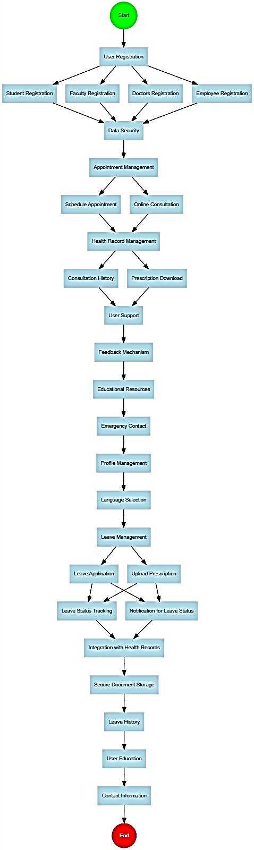

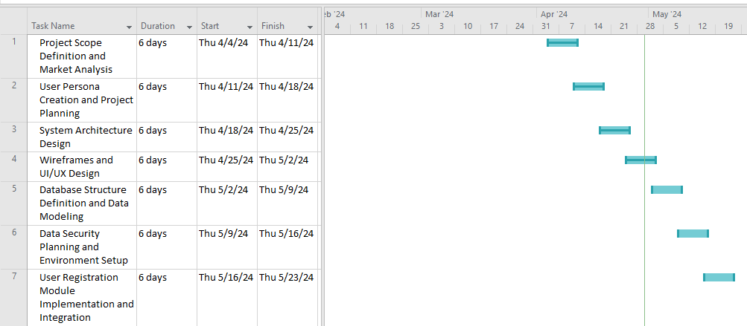

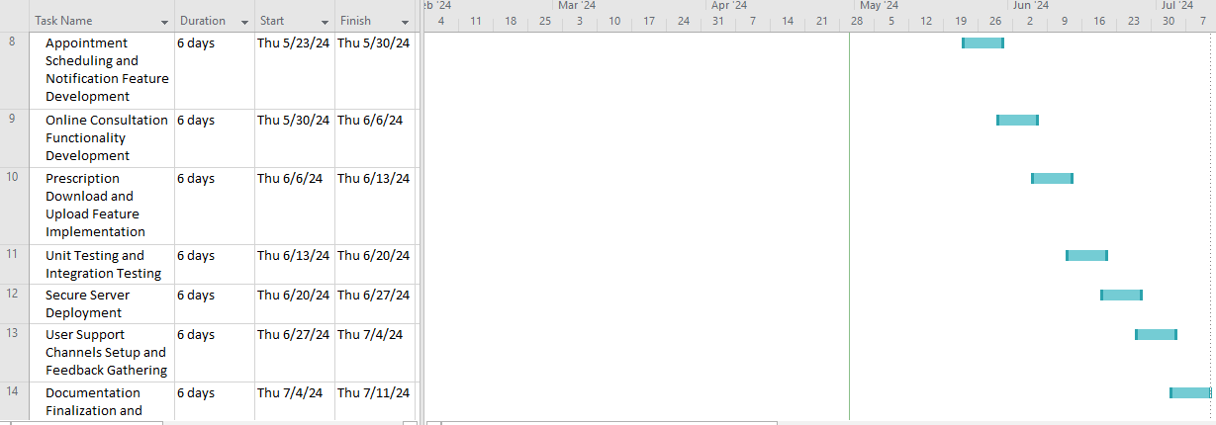

- Key Milestones of the Project / Project Management:

S. No. | Elapsed time since start of the project | Milestone |  | Deliverable
1. | Week 01 – 04
2. | Week 05
3. | Week 06
4. | Week 07
5. | Week 08
6. | Week 09
7. | Week 10
8. | Week 11
9. | Week 12
10. | Week 13
11 | Week 14
12 | Week 15
- Final deliverable of the project (please tick one of the following)
- Hardware system |  | - Software system | - HW/SW integrated system
- Software simulation results |  | - Comparative study | - Web/Mobile App
- Simulator design |  | - Other (please specify)
- Equipment required for the project with Estimated Cost:

- How many PLOs are you covering in this Proposal? List all PLOs

1. Engineering Knowledge  2. Problem Analysis 
3. Design/ Development of Solution  4. Investigation 
5. Modern Tool Usage  6. The Engineer & Society 
7. Environment & Sustainability  8. Ethics 
9. Individual & Team Work  10. Communication 
11. Project Management  11. Lifelong learning 

- How many SDGs are you covering in this Proposal? List all SDGs

1.No poverty  | 10. Reduced inequalities 
2.Zero hunger  | 11. Sustainable cities and communities 
3.Good health and well being  | 12. Responsible consumption and production 
4.Quality education  | 13. Climate action 
5.Gender equality  | 14. Life below water 
6.Clean water and sanitation  | 15. Life on land 
7.Affordable and clean energy  | 16. Peace, justice and strong institutions 
8.Decent work and economic growth  | 17. Partnership for the goals. 
9.Industry innovation and infrastructure 

- WP’s Through This Project:
WP’s | How it is addressed in this Project

Reference:
Attributes | WP1 and some or all of WP2 to WP7
Depth of knowledge required | WP1: A solution requires the use of in-depth computing or domain knowledge and an analytical approach that is based on well-founded principles .One or more of WK3, WK4, WK5, WK6 or WK8
Range of conflicting requirements | WP2: Involves wide-ranging or conflicting technical, computing, and other issues
Depth of analysis required | WP3: Has no obvious solution, and requires conceptual thinking and innovative analysis to formulate suitable abstract models.
Familiarity of issues | WP4: Involve infrequently encountered issues
Extent of applicable codes | WP5: Outside problems encompassed by standards and codes of practice
Extent of stake-holder involvement and conflicting requirements | WP6: Diverse group of stakeholders with widely varying needs
Interdependence | WP7: Many component parts or sub-problems. Is a high-level problem possibly including many component parts or sub-problems

Key for WK (knowledge profile):
WK | Short Name
WK1 | Natural Sciences
WK2 | Mathematics
WK3 | Engineering Fundamentals
WK4 | Specialist Knowledge
WK5 | Engineering Design
WK6 | Engineering Practice
WK7 | Comprehension

Supervisor Signature

